Kevin Geraghty, Chairman  Michael Chizy, Vice Chairman  Ryan Fattman, Clerk  John L. Hebert  Richard Hersom  James A. Smith, Town Administrator | 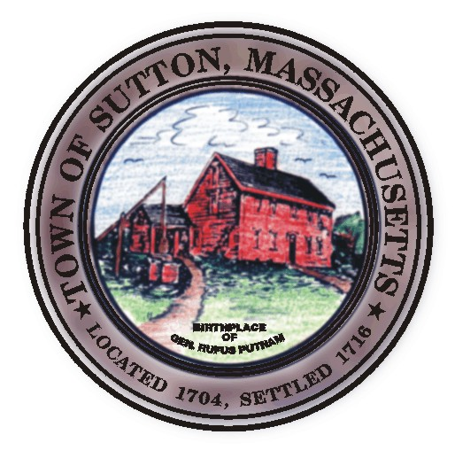 | Sutton Town Hall  4 Uxbridge Road  Sutton, Massachusetts 01590  (508) 865-8727  Fax: (508) 865-8721
Town Of Sutton
Board Of Selectmen

Meeting Agenda

7:00 p.m. – Tuesday, June 3^{rd,} 2008

Sutton Town Hall, Selectmen’s Meeting Room

- Call to Order, Pledge of Allegiance at 7:00 p.m.

- Public Forum: Limited to 5 minutes per topic. Discussion or comments about town employees or agency members shall be avoided so as not to violate individual’s rights.

- Minutes
  - Board of Selectmen minutes from 05/20/08

- Sponsored Agenda and Action Items
2. Board Reorganization
- Transfer Station update PowerPoint presentation
- Joint Agreement Sutton/Douglas Senior Van

- Town Administrator Update
- Announcements
- Selectman’s Roundtable: Correspondence and Business Topics
- Executive Session

Adjournment

